Docker build command and output:
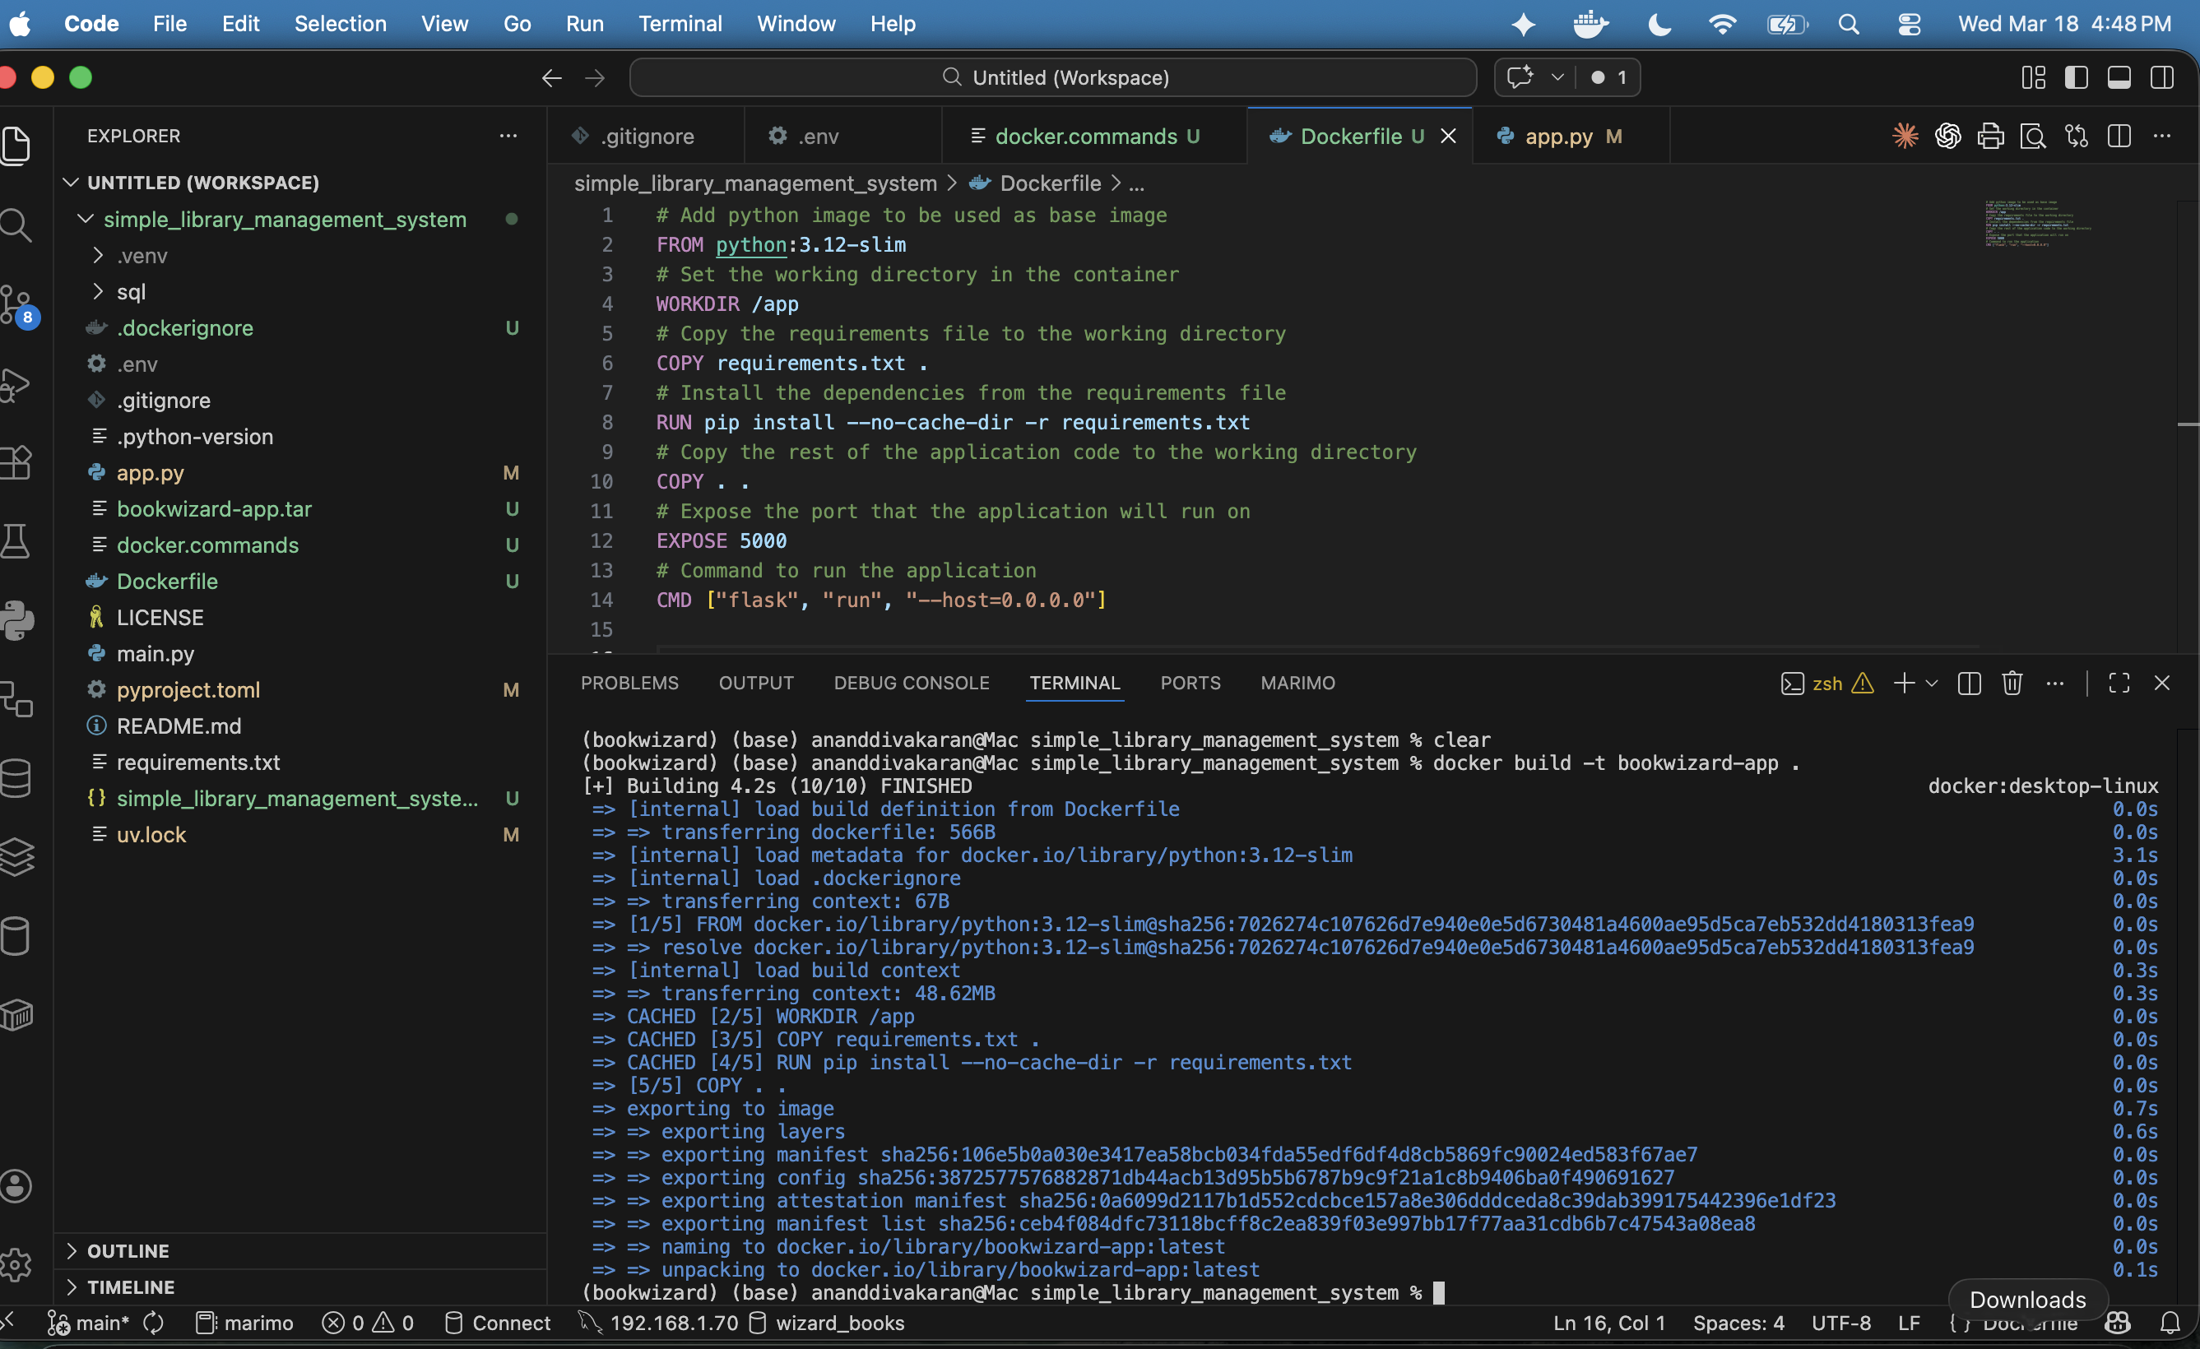

Docker run command and container status (docker ps)
Proof that the application is running in the container:
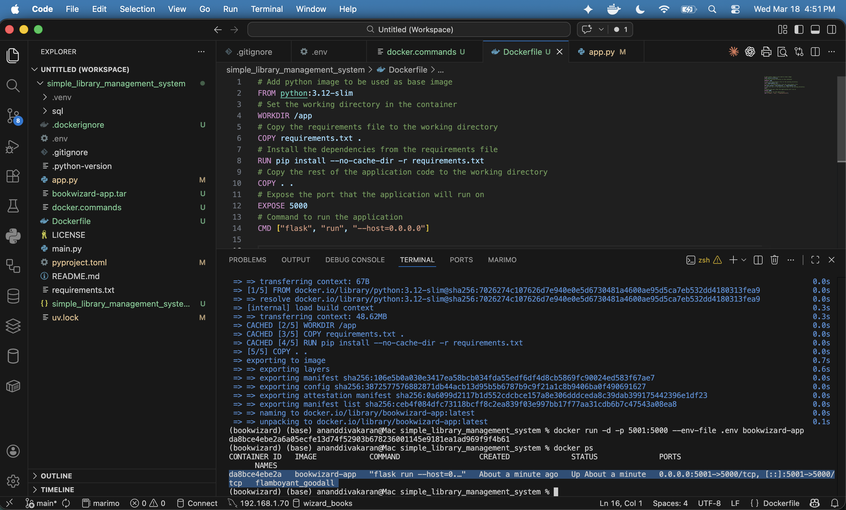
Container in the docker desktop:
